1. Right click the CSV File then Open with Excel Application. Select Choose default program then select Excel if application is not available in the default list.

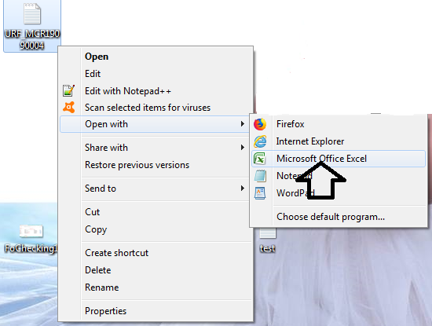

2. Put your answer in COLUMN **J**

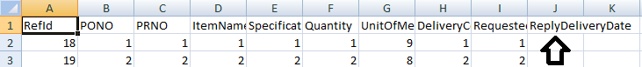

3. **TAKE NOTE :** DO NOT CHANGE ANYTHING IN THE FILE. JUST PUT YOUR ANSWER IN THE ReplyDeliveryDate in **COLUMN J.** DO NOT PUT ANY FORMAT LIKE "BORDER, COLOR ETC.". JUST PUT YOUR ANSWER IN THE ReplyDeliveryDate in **COLUMN J.** THANK YOU!

4. Click SAVE after your updates. Click yes when dialog below will appear.

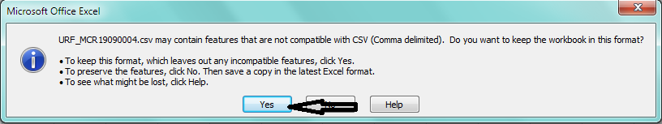

5. Click the Close Button and Click Yes if you ask if you want to save changes.

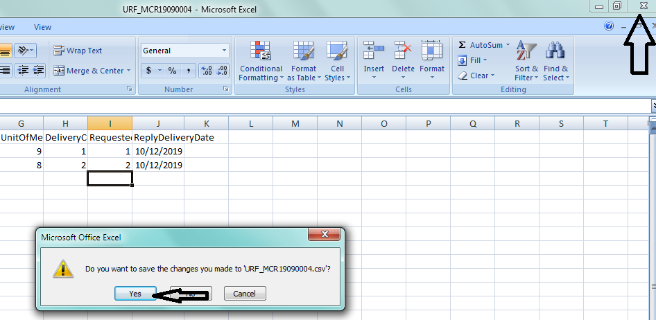

6. SaveAs the file. Click YES to overwrite the existing CSV File or Save into your preffered location if you want.

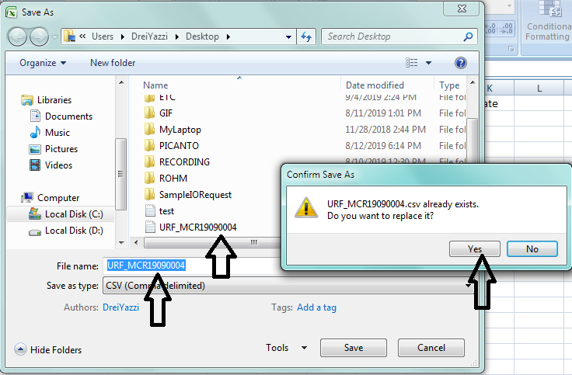



7. You can now send it back to REPI by replying to the original email. Again, like what you usually did in RFQ Email Request, do not put anything in the email and just attached your completed CSV File and your PDF File attachment if there is any.